|  |
| --- |
| Online Test Project  submission By Nikhil Rode  Repository URL: https://github.com/nikhilrode/OnlineTestProjcet.git  Date of Submission 28/06/2023 |
|  |
| **Technologies used:**  Html, CSS, JavaScript, JSON |
| **Html Index.html** |
| <!DOCTYPE html>  <html lang="en">  <head>  <meta charset="UTF-8">  <meta name="viewport" content="width=device-width, initial-scale=1.0">  <title>Java Quiz</title>  <link rel="stylesheet" href="css/app.css">  <link href="[https://fonts.googleapis.com/css2?family=Lato:wght@300;400&display=swap](https://fonts.googleapis.com/css2?family=Lato%3Awght%40300%3B400&display=swap)" rel="stylesheet">  </head>  <body>  <div class="container">  <div id="home" class="flex-center flex-column">  <h1>Java Quiz</h1>  <a class="btn" href="html/quiz.html">Start</a>  </div>  </div>  </body>  </html>  <!DOCTYPE html>  <html lang="en">  <head>  <meta charset="UTF-8">  <meta http-equiv="X-UA-Compatible" content="IE=edge">  <meta name="viewport" content="width=device-width, initial-scale=1.0">  <title>Document</title>  </head>  <body>  </body>  </html> |
|  |

|  |
| --- |
| **quiz.html** |
| <!DOCTYPE html>  <html lang="en">  <head>  <meta charset="UTF-8" />  <meta name="viewport" content="width=device-width, initial-scale=1.0" />  <meta http-equiv="X-UA-Compatible" content="ie=edge" />  <title>Java Quiz</title>  <link href=["https://fonts.googleapis.com/css2?family=Lato:w](https://fonts.googleapis.com/css2?family=Lato%3Awght%40300%3B400&display=swap)g[ht@300;400&display=swap](https://fonts.googleapis.com/css2?family=Lato%3Awght%40300%3B400&display=swap)" rel="stylesheet">  <link rel="stylesheet" href="../css/app.css" />  <link rel="stylesheet" href="../css/quiz.css" />  </head>  <body>  <div class="container">  <div id="quiz" class="justify-center flex-column">  <div id="hud">  <div id="hud-item">  <p class="hud-prefix"> Question  </p>  <h1 class="hud-main-text" id="questionCounter"></h1>  </div>  <div id="hud-item">  <p class="hud-prefix"> Score  </p>  <h1 class="hud-main-text" id="score"> 0  </h1>  </div>  </div>  <h2 id="question">What is the answer to this questions?</h2>  <div class="choice-container">  <p class="choice-prefix">A</p>  <p class="choice-text" data-number="1">Choice 1</p>  </div>  <div class="choice-container">  <p class="choice-prefix">B</p>  <p class="choice-text" data-number="2">Choice 2</p>  </div>  <div class="choice-container">  <p class="choice-prefix">C</p>  <p class="choice-text" data-number="3">Choice 3</p>  </div>  <div class="choice-container">  <p class="choice-prefix">D</p>  <p class="choice-text" data-number="4">Choice 4</p>  </div>  </div>  </div>  <script src="../script/quiz.js"></script> |

|  |
| --- |
| </body>  </html> |
| **end.html** |
| <!DOCTYPE html>  <html lang="en">  <head>  <meta charset="UTF-8" />  <meta name="viewport" content="width=device-width, initial-scale=1.0" />  <meta http-equiv="X-UA-Compatible" content="ie=edge" />  <title>Java Quiz</title>  <link href="[https://fonts.googleapis.com/css2?family=Lato:wght@300;400&display=swap](https://fonts.googleapis.com/css2?family=Lato%3Awght%40300%3B400&display=swap)" rel="stylesheet">  <link rel="stylesheet" href="../css/app.css" />  </head>  <body>  <div class="container">  <div id="end" class="flex-center flex-column">  <h1 id="finalScore"></h1>  <a class="btn" href="quiz.html">Start Again</a>  <a class="btn" href="/">Back to Home</a>  </div>  </div>  <script src="../script/end.js"></script>  </body>  </html> |
|  |

|  |
| --- |
| **CSS** |

# app.css

:root{

background: rgb(97, 103, 15);

background: linear-gradient(90deg, rgb(232, 180, 10) 100%, rgba(0,212,255,1)

100%, rgb(36, 22, 0) 100%);

font-size: 58%;

}

*{

box-sizing: border-box;

font-family: 'Lato', sans-serif; margin: 0;

padding: 0;

color: #333;

font-weight: 400; color: white;

}

.container{

max-width: 1140px; margin: 0 auto;

}

h1,

h2,

h3,

h4 {

margin-bottom: 1rem;

}

h1{

}

font-size: 6rem; color: rgb(94, 2, 2); margin-bottom: 5rem;

h1 > span{

font-size: 2.4rem; font-weight: 500;

}

h2{

}

h3{

}

font-size: 4.2rem; margin-bottom: 4rem; font-weight: 700;

font-size: 2.8rem; font-weight: 500;

.container{ width: 100vw; height: 90vh; display: flex;

justify-content: center;

align-items: center; max-width: 80rem;

}

.container >*{ width: 100%;

}

.flex-column { display: flex;

flex-direction: column;

}

.flex-center {

justify-content: center; align-items: center;

}

.justify-center {

justify-content: center;

}

.text-center {

text-align: center;

}

.hidden { display: none;

}

.btn {

font-size: 2rem; padding: 1rem 0; width: 30rem;

text-align: center;

border: 0.1rem solid #bef80e; margin-bottom: 2.5rem;

text-decoration: none; color: rgb(34, 16, 228); background-color:#22e622; border-radius: 15px; font-weight: 400;

}

.btn:hover { cursor: pointer;

box-shadow: 0 0.4rem 1.4rem 0 rgba(86, 185, 235, 0.5); transform: translateY(-0.1rem);

transition: transform 150ms;

}

.btn[disabled]:hover { cursor: not-allowed; box-shadow: none; transform: none;

}

form {

width: 100%; display: flex;

flex-direction: column; align-items: center;

}

input { color:#e67e22;

margin-bottom: 2.5rem; width: 30rem;

padding: 1.2rem; font-size: 1.8rem; border: none;

box-shadow: 0 0.1rem 1.4rem 0 rgba(235, 133, 86, 0.5);

}

input::placeholder { color: #aaa;

}

# quiz.css

*{

font-family: 'Lato',sans-serif; word-spacing: 2.5px;

font-weight: 400; letter-spacing: 1.5px;

}

h2{

font-weight: 400; color: black;

}

.container{

max-width: 1140px; margin: 0 auto;

}

.choice-container { display: flex;

margin-bottom: 1.5rem; width: 100%;

font-size: 1.8rem;

border: 0.1rem solid rgb(86, 165, 235, 0.25); background-color: black;

border-radius: 15px;

}

.choice-container:hover { cursor: pointer;

box-shadow: 0 0.4rem 1.4rem 0 rgba(104, 50, 210, 0.5); transform: translateY(-0.1rem);

transition: transform 150ms;

}

.choice-prefix {

padding: 1.5rem 2.5rem; background-color: #e67e22; color: rgb(49, 21, 232); border-top-left-radius: 15px;

border-bottom-left-radius: 15px;

}

.choice-text { padding: 1.5rem; width: 100%;

}

.correct {

background-color: #4e7e8a;

}

.incorrect {

background-color: #801336;

}

#hud {

display: flex;

justify-content: space-between; text-transform: uppercase;

}

.hud-prefix {

text-align: center; font-size: 2rem;

color: rgb(49, 21, 232);

}

.hud-main-text {

text-align: center; color:black;

}

|  |
| --- |
| **Javascript:**  **quiz.js** |
| const question = document.getElementById("question");  const choices = Array.from(document.getElementsByClassName("choice-text")); const questionCounterText = document.getElementById("questionCounter"); const scoreText = document.getElementById("score");  let currentQuestion = {};  let acceptingAnswers = false; let score = 0;  let questionCounter = 0; let availableQuesions = [];  let questions = []; fetch("../json/questions.json")  .then(res => { return res.json();  })  .then(loadedQuestions => { console.log(loadedQuestions); questions = loadedQuestions; startQuiz();  });  const CORRECT_BONUS = 10; const MAX_QUESTIONS = 5;  startQuiz = () => { questionCounter = 0;  score = 0;  availableQuesions = [...questions]; getNewQuestion();  };  getNewQuestion = () => {  if (availableQuesions.length === 0 || questionCounter >= MAX_QUESTIONS) { localStorage.setItem('mostRecentScore', score);  return window.location.assign("../html/end.html");  }  questionCounter++;  questionCounterText.innerText = `${questionCounter}/${MAX_QUESTIONS}`;  const questionIndex = Math.floor(Math.random() * availableQuesions.length); currentQuestion = availableQuesions[questionIndex];  question.innerText = currentQuestion.question;  choices.forEach(choice => {  const number = choice.dataset["number"]; choice.innerText = currentQuestion["choice" + number];  });  availableQuesions.splice(questionIndex, 1); acceptingAnswers = true;  }; |

|  |
| --- |
| choices.forEach(choice => { choice.addEventListener("click", e => {  if (!acceptingAnswers) return;  acceptingAnswers = false;  const selectedChoice = e.target;  const selectedAnswer = selectedChoice.dataset["number"];  const classToApply =  selectedAnswer == currentQuestion.answer ? "correct" : "incorrect";  if (classToApply === "correct") { incrementScore(CORRECT_BONUS);  }  selectedChoice.parentElement.classList.add(classToApply); setTimeout(() => {  selectedChoice.parentElement.classList.remove(classToApply); getNewQuestion();  }, 400);  });  });  incrementScore = num => { score += num; scoreText.innerText = score;  }; |
| **end.js** |
| const username = document.getElementById('username');  const saveScoreBtn = document.getElementById('saveScoreBtn'); const finalScore = document.getElementById('finalScore');  const mostRecentScore = localStorage.getItem('mostRecentScore'); finalScore.innerText = "Total Score is: "+mostRecentScore+ " points!";  username.addEventListener('keyup', () => { saveScoreBtn.disabled = !username.value;  });  saveHighScore = (e) => { e.preventDefault();  }; |
|  |

|  |
| --- |
| **JSON**  **questions.json** |
| [  {  "question": "Which component is used to compile, debug and execute the java programs?", "choice1": "JRE",  "choice2": "JIT",  "choice3": "JDK",  "choice4": "JVM", "answer": 3  },  {  "question": "Which one of the following is not a Java feature?", "choice1": "Object-oriented",  "choice2": "Use of pointers", "choice3": "Portable",  "choice4": "Dynamic and Extensible", "answer": 2  },  {  "question": "Which of these cannot be used for a variable name in Java", "choice1": "identifier & keyword",  "choice2": "identifier", "choice3": "keyword",  "choice4": "none of the mentioned", "answer": 3  },  {  "question": "Which of the following is not an OOPS concept in Java?", "choice1": "Polymorphism",  "choice2": "Inheritance", "choice3": "Compilation", "choice4": "Encapsulation", "answer": 3  },  {  "question": "What is not the use of “this” keyword in Java?",  "choice1": "Referring to the instance variable when a local variable has the same name", "choice2": "Passing itself to the method of the same class",  "choice3": "Passing itself to another method",  "choice4": "Calling another constructor in constructor chaining", "answer": 2  }  ] |
|  |

**Screenshots: HomePage : index.html**

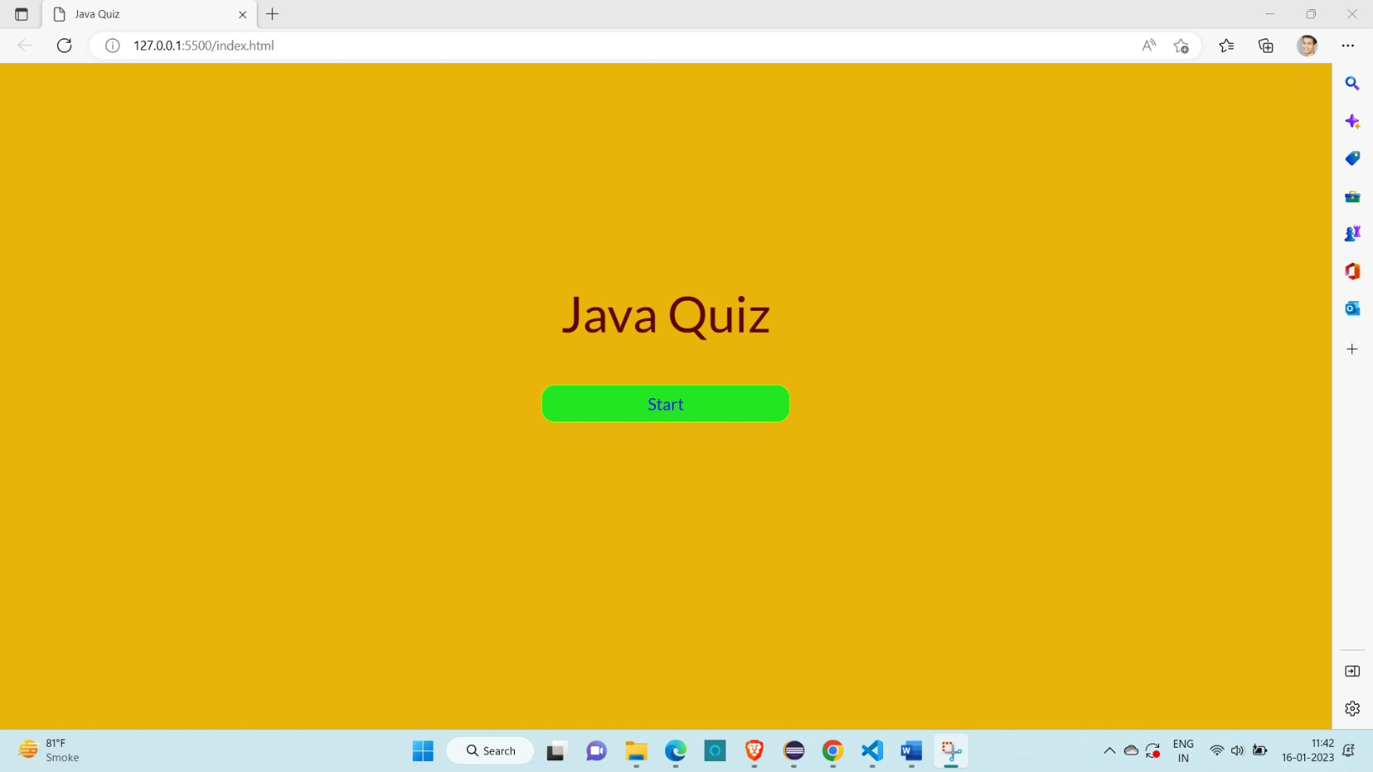

**quiz.html**

